Step 1: Download the “clean” folder from ETL. This folder contains all 13 cleaned .csv files.
Step 2: Download NHL – Load_Postgres.ipynb
Run this file using Jupyter Notebook

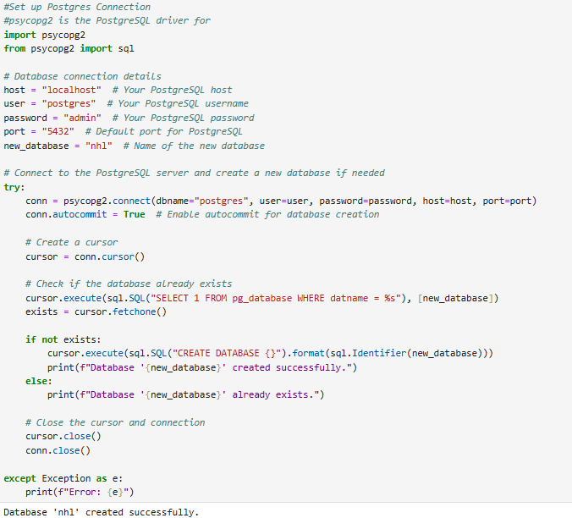
input your postgres connection info:
host
user
password
port
leave the new_database name as nhl
Once successful, it should say “Database ‘nhl’ created successfully.

Step 3: Run the Create Database in PostgreSQL
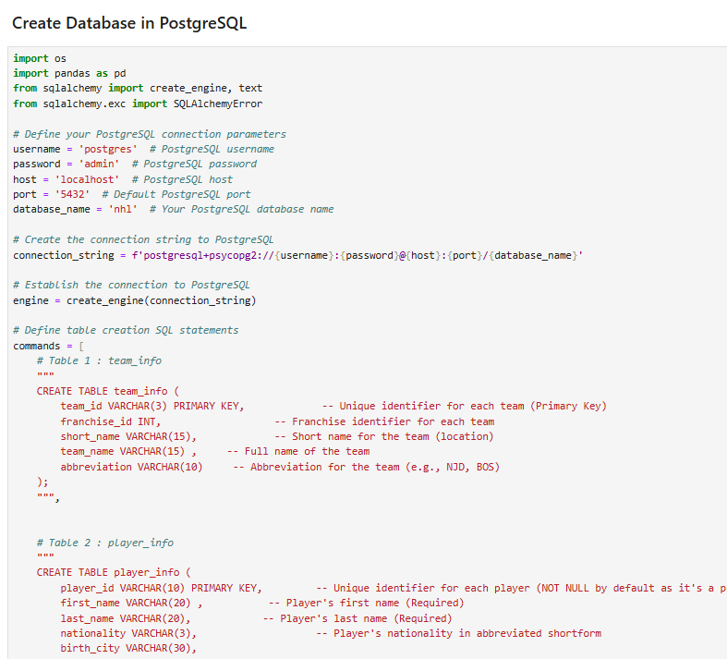
input your postgres connection info:
host
user
password
port
do not change new_database name
Once successful : it should say “Tables created successfully.”
Step 4: Run the Upload Dataframe to PostgreSQL. It will take minimum of 20 minutes to run.
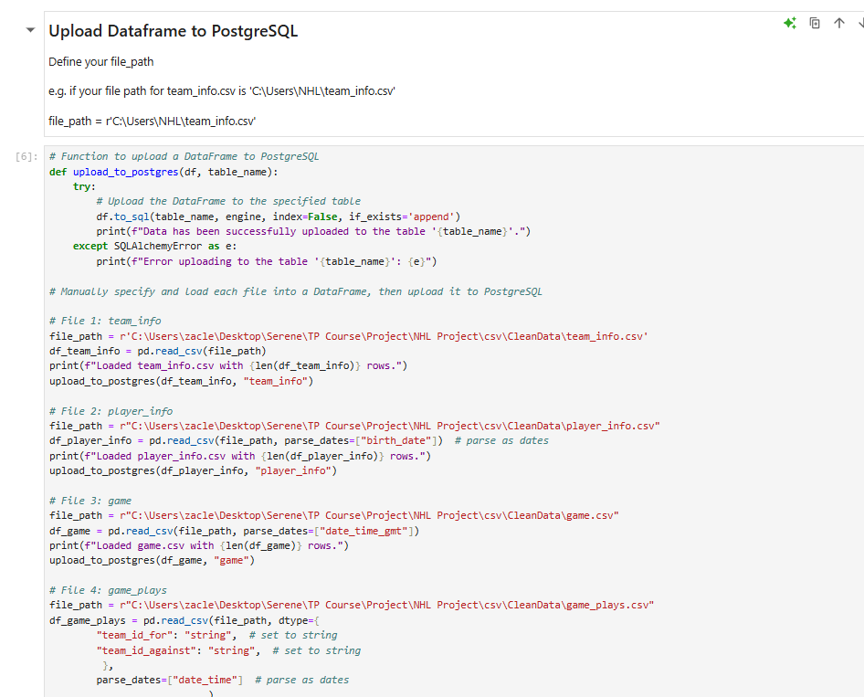
Re-define your file_path manually for all the 13 .csv files in the folder where you store them.

e.g. if your file path for team_info.csv is
'C:\Users\NHL\team_info.csv'
file_path = r'C:\Users\NHL\team_info.csv'

make sure to include the ‘r’ in front of your file path.

Once successful, it should look like this.
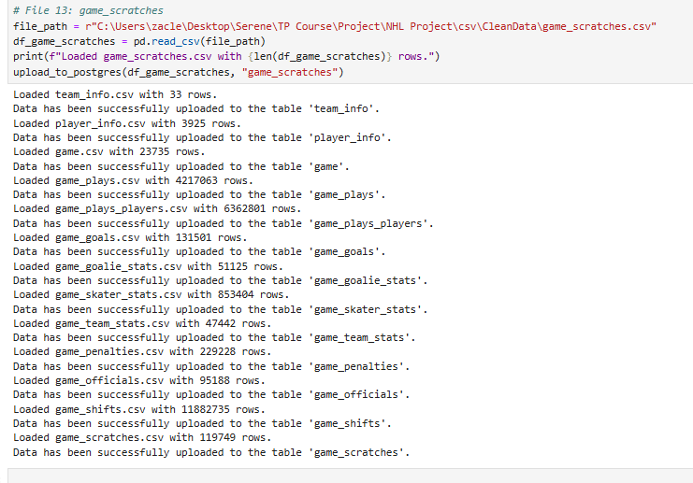
Challenge : Data Type Mismatch When Loading CSV Files into PostgreSQL via Jupyter Notebook
I am defining the file path one by one because, even after I enforced the data type of a column to string, for example and save the files to .csv
When pandas reads a CSV file, it automatically detects the data types of each column based on the data. If a column contains only numeric values, pandas will infer its datatype as int or float. If you've saved the column as string in the database but the column contains numeric values, pandas will still treat it as numeric when you load it back.
So to overcome this, I have to explicitly define the data types for columns when reading the CSV file using the dtype parameter in pd.read_csv().
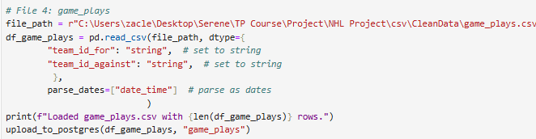

Step 5: Open your PostgreSQL (PgAdmin4)
The nhl database should be created
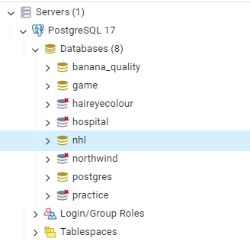
Check that the tables are created.
Check that the tables are populated with data.
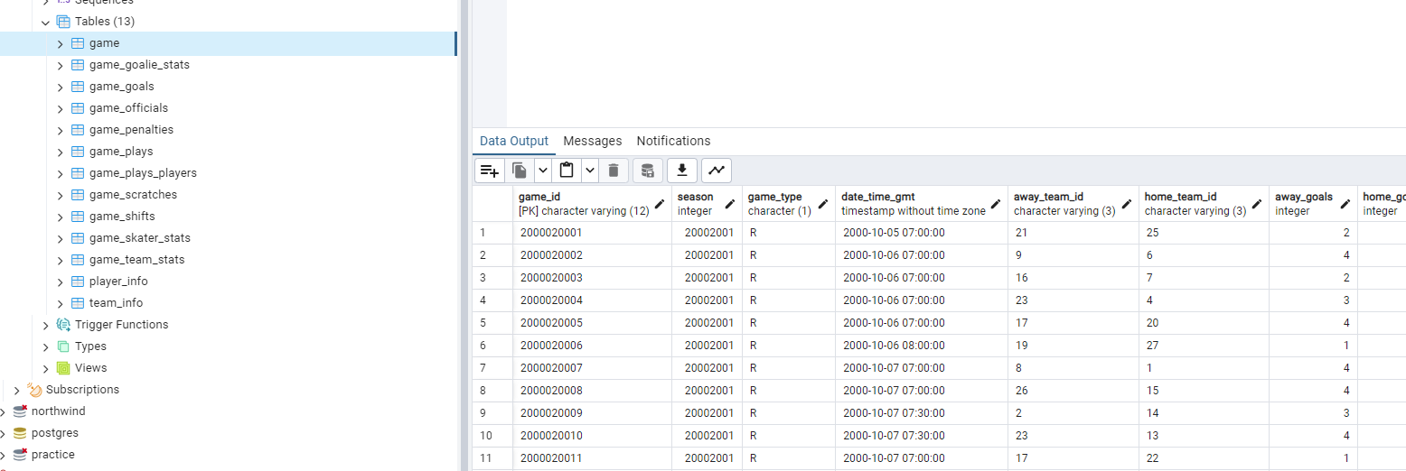
Step 6: Click on the Query Tool and first open the “NHL_Debug” file.
This is where I debug issues in the uploaded clean data so that
I have only included fact tables
Execute each query, one by one, in sequence. This will take a while.

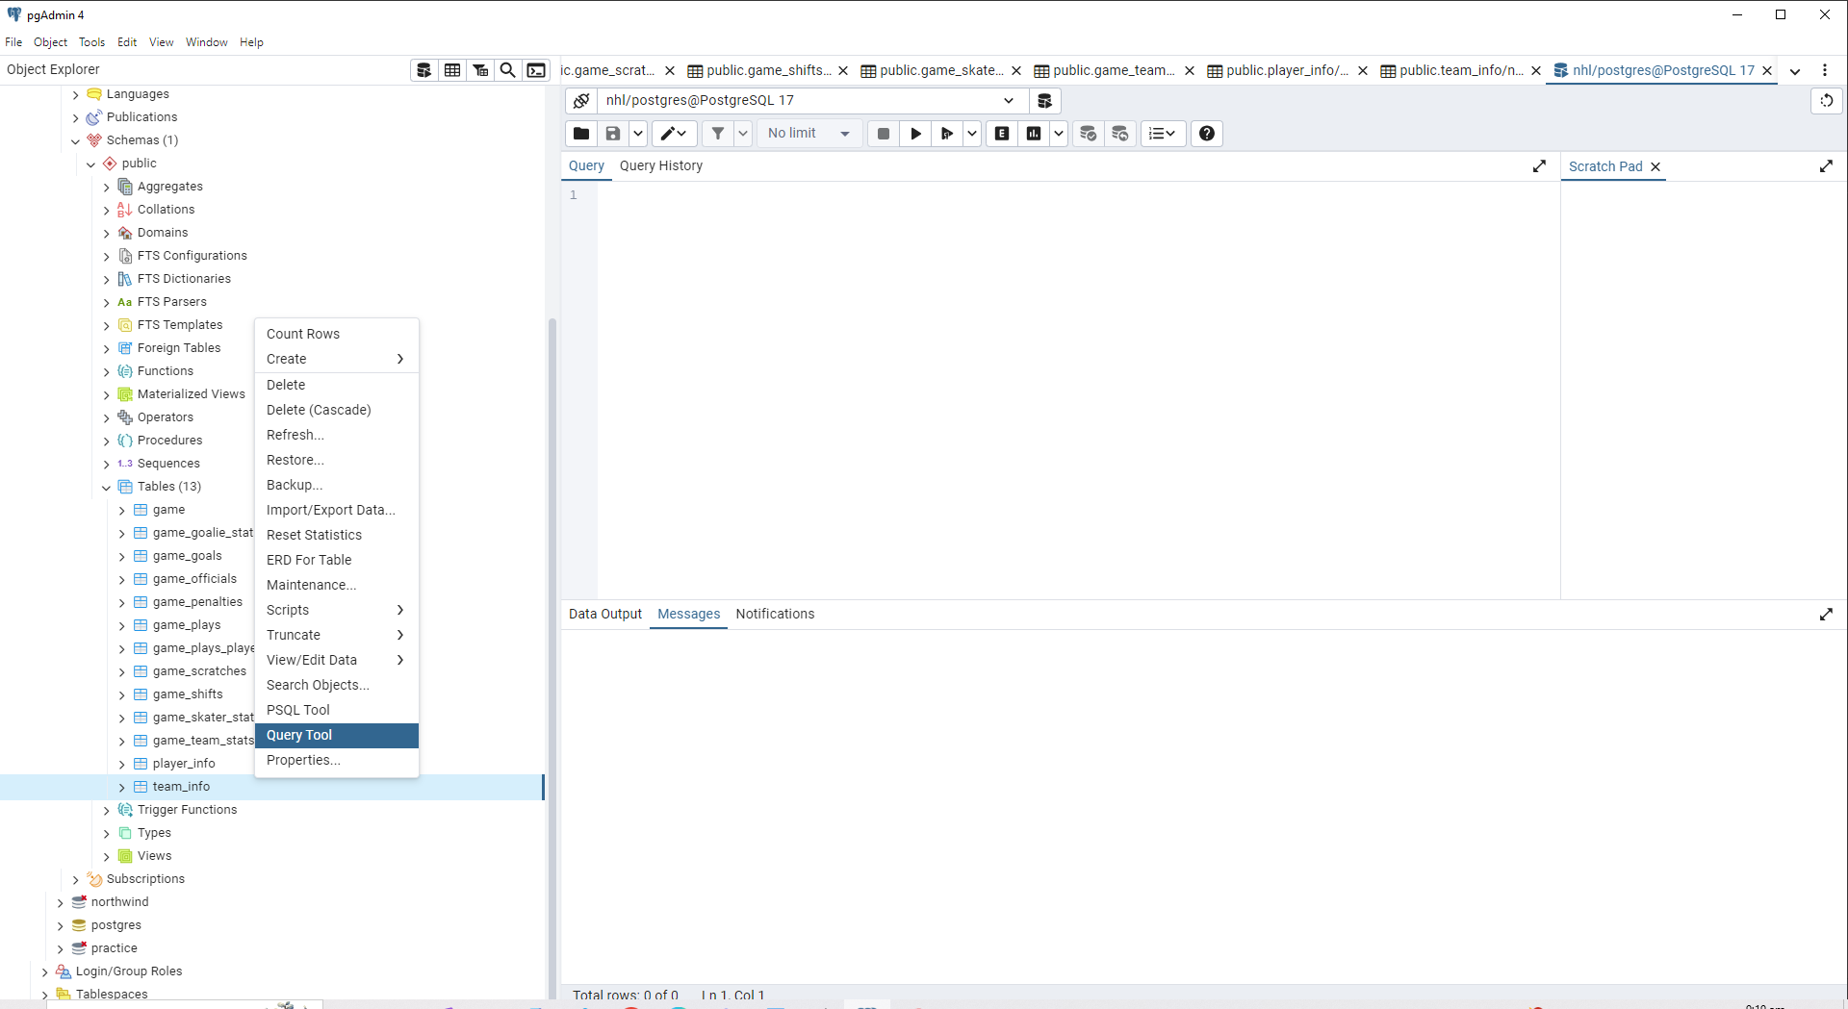 | 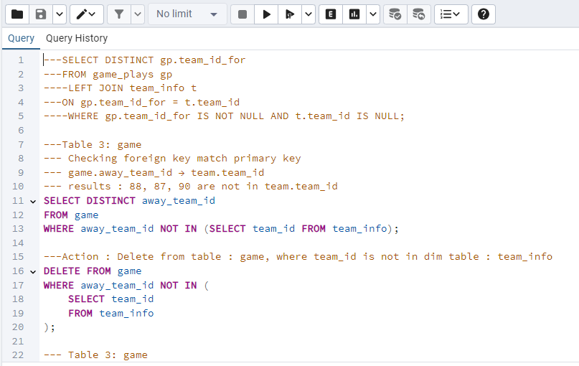

Step 7 : Click on the Query Tool and run the “NHL_ForeignKeyConstraint” file.
Run each query, one by one to create the Foreign Key relationship. There are 18 queries.

DONE!

